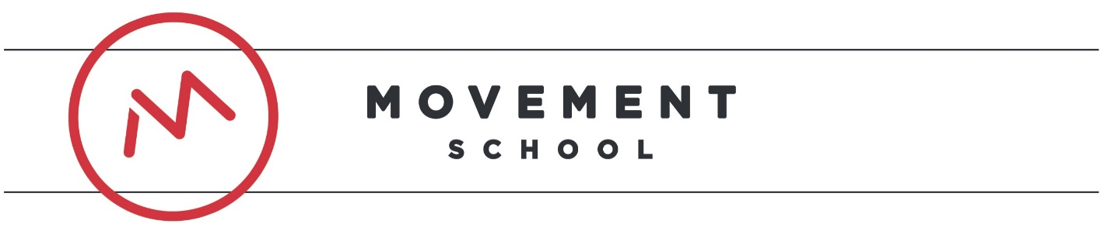
Movement School East
Front Office Managaer Job Description

Movement East is a free, public charter school primarily serving the east Charlotte community through providing a school that is committed to excellence in character and academics. We believe in creating life-long learners who have a clear sense of self, a genuine appreciation for others, and a commitment to positively impacting our community and world. We are seeking a Front Office Manager to join our team to serve our students, families, and community.

Job Title: | Front Office Manager
General Summary: | The Front Office Manager leads and manages the front office of our school. S/He embodies the friendly, warm, and caring nature of our school while ensuring the front office operates smoothly and effectively. With attention to detail and organization, the Front Office Manager is the epitome of hospitality.  The Front Office Manager supports the Director of Operations and other members of the leadership team to support systems and procedures
Duties and Responsibilities: | - Work with the School Director and Director of Operations to create/implement systems and procedures to ensure the safety and well-being of our students and families within the front office areas (i.e. reception area, lobby, administrative wing, etc.)  - Receive and manage phone calls to the school  - Oversee the daily operations of the front office areas  - Oversee the staff lounge  - Support the Director of Operations to ensure supplies are stocked throughout the school year  - Support the Director of Operations with student enrollment  - Support the Director of Operations with managing staff leave requests  - Support the school leadership team in constructing class rosters  - Support the school leadership team in scheduling meetings/events  - Perform all other duties as assigned by the School Director
Skills and Characteristics: | - Commitment to the mission of Movement School East  - Demonstrate a relentless drive to improve the minds, character, and lives of students both in and out of school  - Eagerness to learn and a growth mindset  - High level of personal organization and planning  - Openness to feedback, and confidence in giving feedback  - Excellent communication skills with diverse constituents (teachers, students, parents, and other stakeholders)  - Team player who is mature, humble, has a strong work ethic, follows through, and is committed to the challenge of excellently educating all students  - Strong critical thinking skills  - Demonstrate grit and personal responsibility  - Ability to think strategically and innovatively  - Proactive problem-solver who can work successfully in a high-paced environment  - Excellent communication skills, both verbal and written  - Excellent computer skills (including Microsoft Office, Word, Excel and Access)  - Ability to learn new systems and programs quickly  - Strong time management skills; ability to manage multiple tasks simultaneously and meet tight deadlines  - Ability to maintain a calm, professional demeanor in the face of competing demands and external pressures  - Display maturity and ability to work independently  - Welcoming and positive presence, sense of humor
Education and Qualifications: | - A high school diploma with a 3.0 GPA (min.)  - Experience working with a diverse population of people
Compensation: | Salary for this position is competitive and commensurate with experience. Additionally, Movement Schools offer a comprehensive benefits package.

