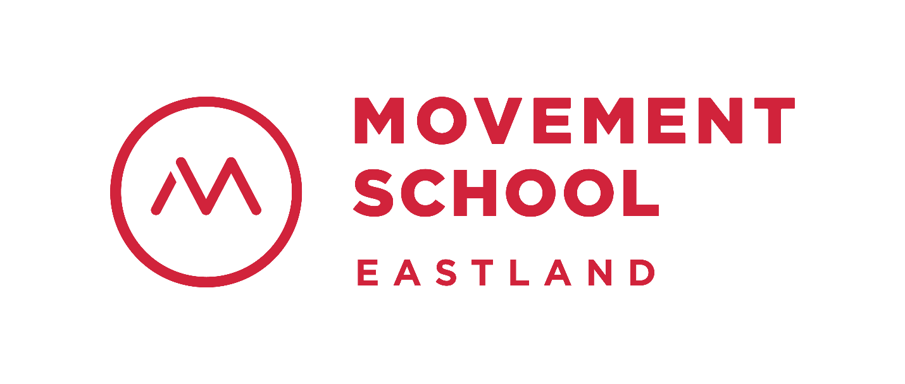
Frequently Asked Questions:
Q: What type of school is Movement School Eastland?
A: Movement School Eastland is a charter school. Charter schools are public schools
of choice that are authorized by the North Carolina State Board of Education and
owned and operated by an independent non-profit board of directors.

Q: Who can attend Movement School Eastland?
A: Movement School Eastland is open to all students who reside in North Carolina.
While our mission is to serve students and families within the East Charlotte
community, all students who reside in North Carolina are welcome.

Q: Does Movement School Eastland require testing for admissions?
A: No testing is required for admission to Movement School Eastland.

Q: Does Movement School Eastland use a lottery for admissions?
A: As mandated by NC Charter School law, when demand exceeds the spaces
available int eh school, a charter school must hold a randomized, blind lottery to
determine which students are admitted or preference students by need or
location.

Q: How do I apply to Movement School Eastland?
A: Applications for the 2020-2021 school year are open! Visit our website
www.movementschool/east or contact Monica Bernot
(monica.bernot@movementschool.com and 704-879-5958). Our application
deadline is 11:59pm Tuesday, February 11, 2020.

Q: What grades does Movement School Eastland serve?
A: For the 2020-2021 school year, Movement School Eastland will launch with grades
kindergarten and first (K-1st) and add a grade each year up to 6th grade.

Q: Does Movement School Eastland provide bus transportation?
A: Yes. Movement School Eastland provides free bus transportation within five miles
of the school.

Q: Does Movement School Eastland provide meals?
A: Yes. Movement School Eastland provides breakfast and lunch through the
National School Lunch Program. A local caterer provides meals to students daily.

Q: Is there an afterschool program?
A: Yes. Movement School Eastland provides an afterschool program for students.

Q: Are students required to wear uniforms?
A: Yes. Movement School Eastland uses a uniformed dress code to ensure all
students feel welcomed, valued, and a part of our school family.

Q: Movement School Eastland is on a modified year-round calendar. What does this
mean?
A: A modified year-round calendar is one that has longer breaks in the fall and spring
(usually 10 days or more), and a shorter summer break (usually 6 weeks).

Q: What are the school hours for students?
A: School hours are 8:00am-3:15pm Mondays, Tuesdays, Thursdays, & Fridays; and
8:00am-12:15pm on Wednesdays (Early Dismissal)

Q: I am excited about Movement School Eastland! How can I help spread the
word?
A: We appreciate and welcome your help! Check out and follow our Facebook page
@MovementSchoolEastland for updates on our school. If you are interested in
hosting an interest gathering, contact our School Director, Barbara Robinson
(Barbara.robinson@movementfoundation.org).

